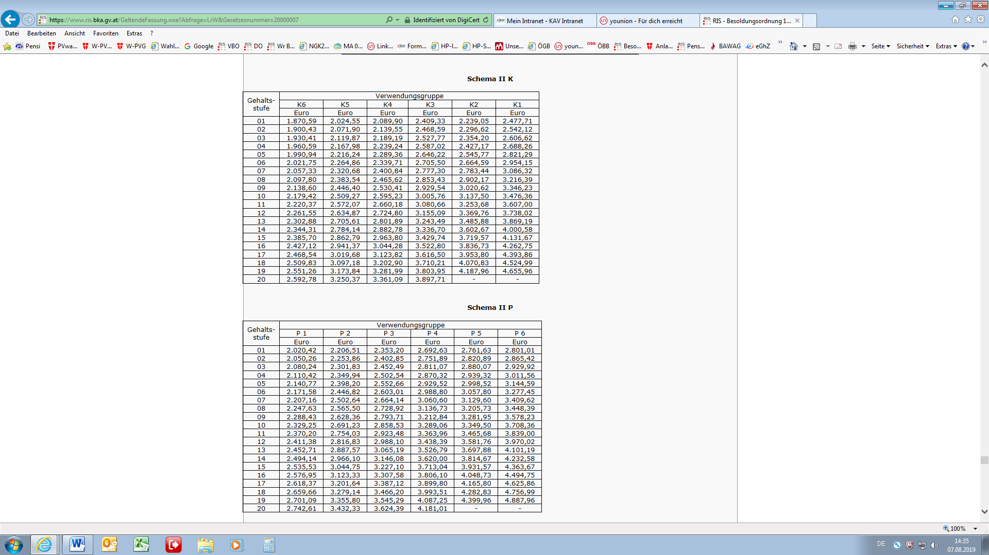**BeamtInnen _ 2019**